Publisher: Ada Smith

Platform: Unity

System: HTC Vive

Simple Sword Script (free to use and modify as see fit)This is as easy as dragging unto controllers, from their add the sword prefab and the transform for un-equip and equip position illustrated in the diagram below.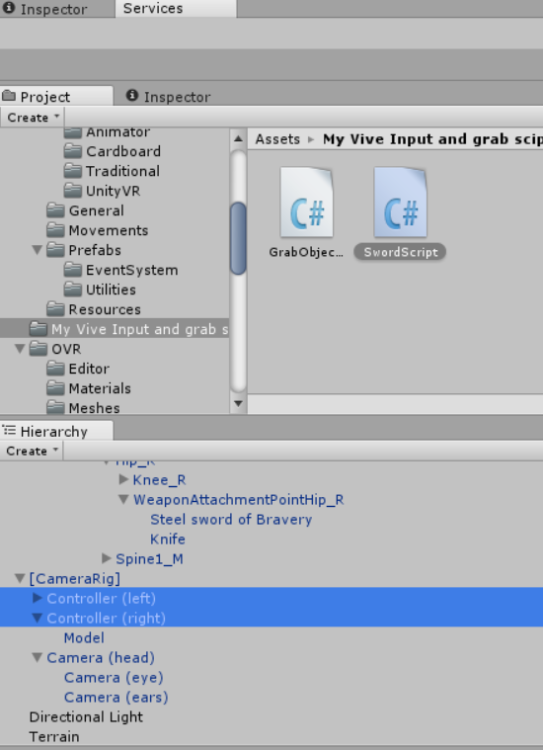

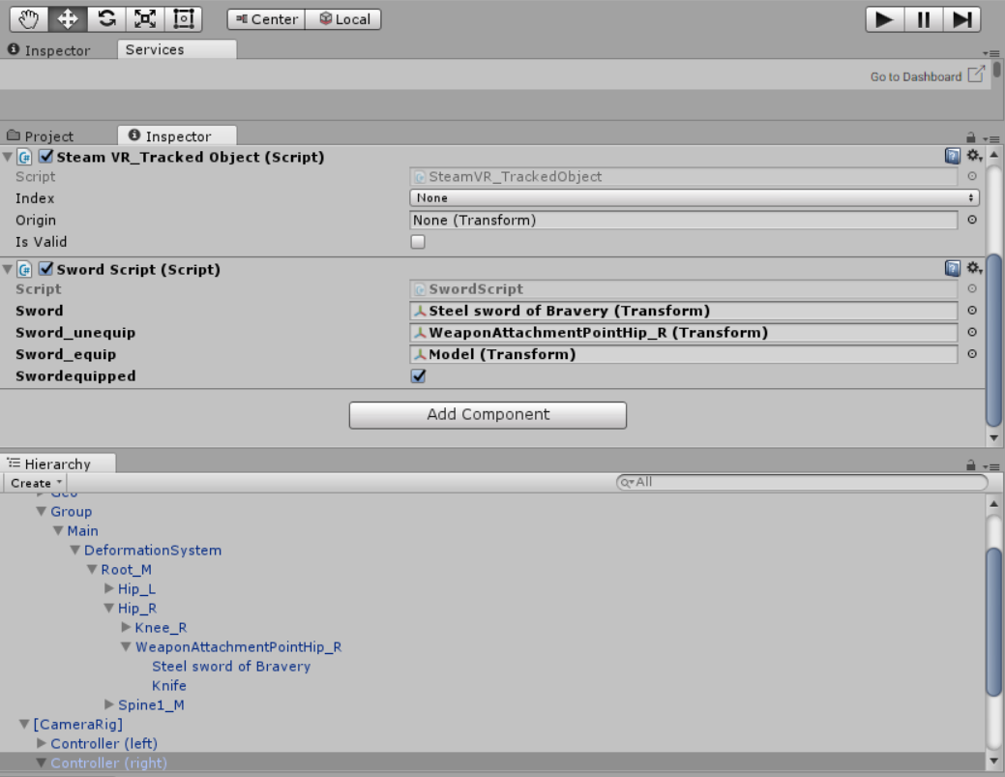

The Sword prefab should already be parented to the player in whatever transform position who wish to have it as for un-equip. Adding the sword to the script is as simple as dragging prefab into the sword slot then the un-equip position into its and the equip into its position.

Here is the Youtube video Link

https://www.youtube.com/watch?v=jMP5RmUsDAU